AERO1005 MATLAB Coursework 2

Author: Yixin Ding
Student ID: 20719599
Date of report: 2026.4.27

Task 1
a) Thermistor Circuit Implementation with Arduino UNO:
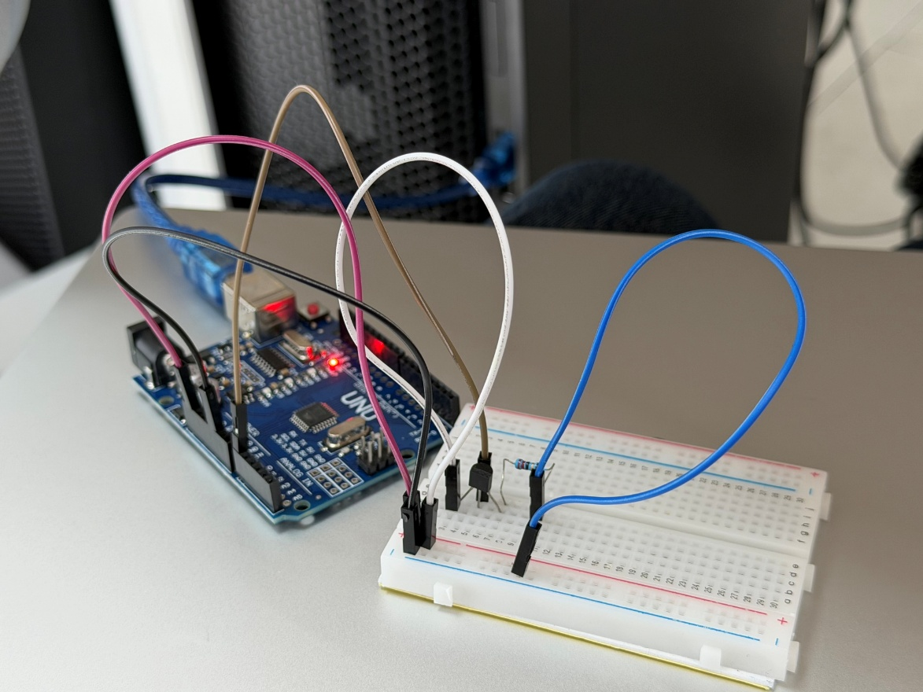
c) Temperature Variation Over Time:
